MotoSim - Maintain TCP Location During Robot Place Adjustment

Introduction
This will explain how to tweak the robot placement if there is an issue. Like arm and tooling interference.

Locking down the TCP
Open the position panel, which can be located here.
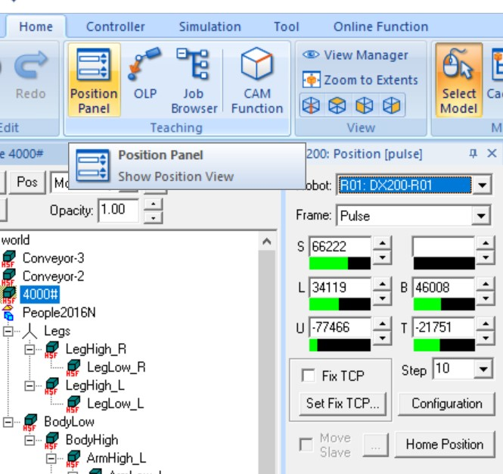

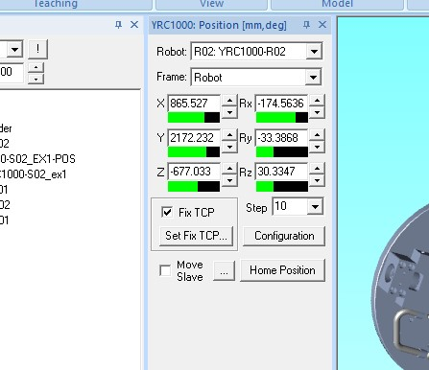
Check the box for “Fix TCP”.

You can now jog the robot around with the set position, by right clinking on the robot in the CAD tree and then click on Set position. If the robot is on a riser, then you can set position of the riser with the same effect on the robot.
Once the robot arm, wrist or tool is clear and good, you can then click OK and keep that position.

Conclusion
This is an extremely useful tool during setup or even when you get into programming and run into a reach or interference issue. Don’t forget to uncheck the “Fix TCP’ box when you have finished updating the robot’s position, or you won’t be able to JOG the robot for programming.

