Resetting Accumulation Time in the Arc Weld Diagnosis Window

Introduction
The Arc Weld Diagnosis window allows you to customize how often your contact-tip needs replaced and the nozzle needs cleaned based on the accumulated amount of welding time. You can set whether work can continue or should stop when one of these conditions are in violation. You can also see how often arc retry, arc restart, and automatic anti-stick have been used. If you have Simple Connect and the Tower Beacon installed, when a violation occurs there will be a message reporting “WELDING CONSUMABLE LOW OR REQUIRED MAINTENANCE” and the beacon will have a cyan light. This document will cover the 2 ways accumulation time can be reset.
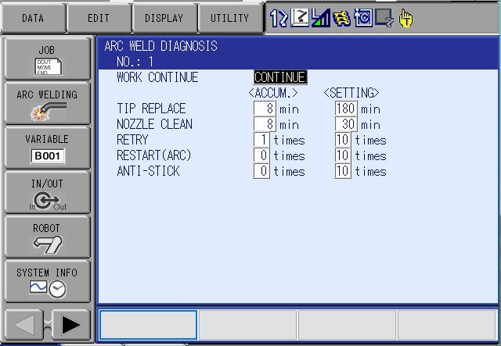

Operator Intervention
This method requires an operator to manually reset the accumulation time. Start by selecting the main menu tab labeled ARC WELDING, then select the ARC WELD DIAG tab. You will then cursor down to highlight the accumulated time and press select. A pop-up window will appear asking to ‘Clear Data?”, select Yes. The accumulated time will be reset back to 0 and any message indicating maintenance required will be cleared.
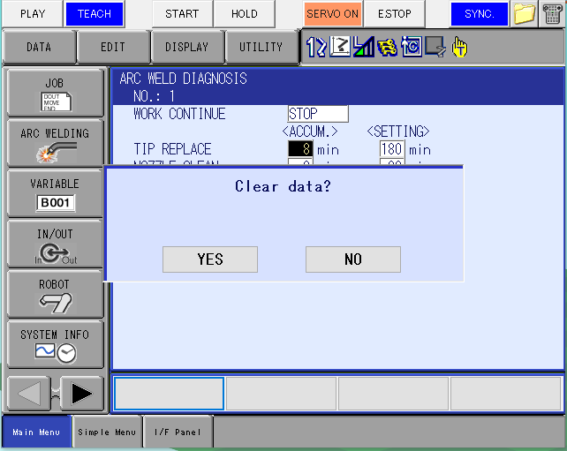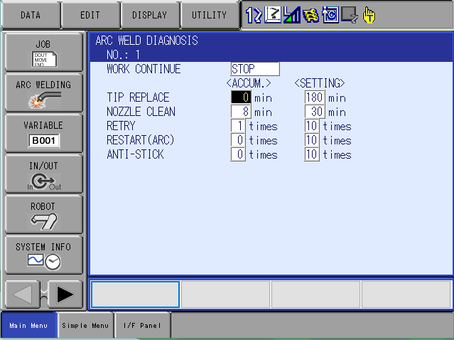

Reset Programmatically
This is the most preferred method by production staff and Integrators as it requires no human intervention and is handled by program logic. First you need to know the logical addresses of the 2 specific inputs that are dedicated to this function. Specific Input #900 Tip Changed:1 logical address #41133, and Specific Input #901 Nozzle Cleaned:1 logical address #41134. You will also need to dedicate 2 General Purpose Outputs that will need to be modified in the ladder to drive these specific inputs. In this example we are using General-Purpose Input #1 logical address #10010, and General-Purpose Input #2 logical address #10011. All you need to do now is pulse the output at the end of your clean or tip change routines to reset the accumulated time.
